SUPPORTING DOCUMENTS  Computer Professionals, Inc. | Document Code : TM-SP-SD-10
SUPPORTING DOCUMENTS  Computer Professionals, Inc. | Issue No. : 1 | Revision No.: 0
Section: 11.0 Special Projects | Effective Date: 01 April 2016
Title : Performance Testing Report

Note: Print this page only when adding / amending / deleting a document. If using this document as a record, this Revision History page can be omitted.

REVISION HISTORY

Issue no | Revision no | Date | Description of Changes | Reason for Revision | Revised by
1 | 0 | 01 Apr 16 | Creation of Document |  | ARAlacar
TM-BR-MG- 11 Rev00, 05302012

<CLIENT>
<PROJECT NAME>

PERFORMANCE TESTING REPORT
July 1, 2013

Introduction
This document contains results of the <Project Name> Performance Tests. Results of these tests should provide basis for assessing the acceptability of the application’s performance given the current application environment and for suggesting actions to improve performance.

Testing Environment
Web Server Configuration:

Application Server Configuration:

Database Configuration:
DB CONFIGURATION | UAT | PROD
Max Connection | Will depend on Max Session* | Will depend on Max Session*
Max Session | 247** | 472**
Max Processes | 150 | 300
*One connection can have multiple concurrent sessions
** Based on oracle configuration of (1.5 * Max Processes) + 22

Network Configuration:

How We Tested
- We developed a load-testing script using the automated testing tool Apache Jmeter that simulates multiple concurrent users accessing the Customer Portal on the UAT environment.
- We simulated 1000, 800 and 600 concurrent users accessing the same function within a one second interval.
- We ran the test scripts for 1000 concurrent users on the SIT environment for comparison.

What We Tested
We tested the following functions in the Customer Portal Application:
- Registration
- Login
- Forgot Password
- Forgot Username
- My Policy Summary
- Basic Policy Information
- Coverage and Financial
- View SOA
- Payments and Benefits History
- Survey

Test Results
- Test Scenario 1: 1000 Users within a 1 second interval

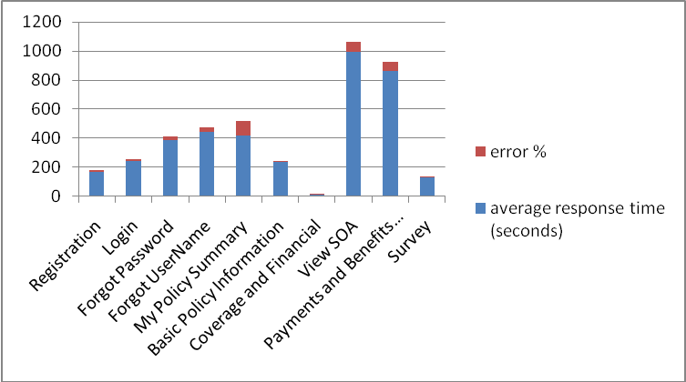

- Test Scenario 2: 800 Users within a 1 second interval

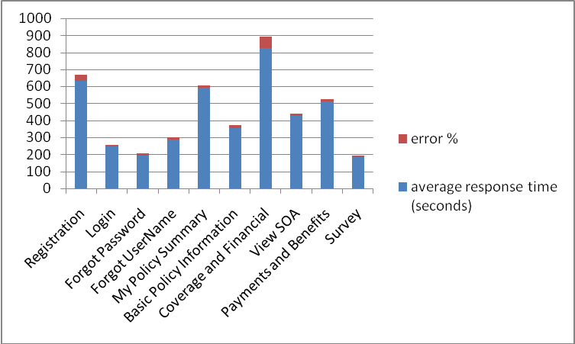

- Test Scenario 3: 600 Users within a 1 second interval

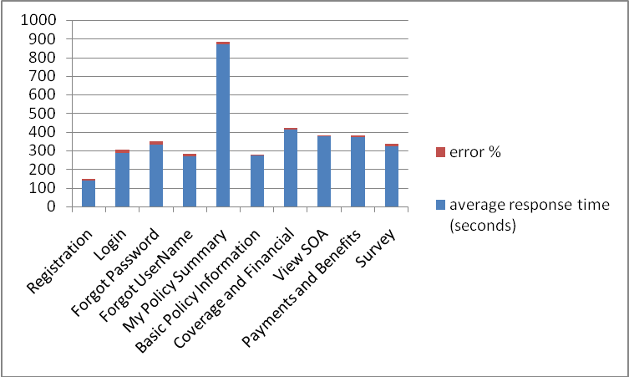

- Test Scenario 4: 100 Users within a 100 second interval
Test Cases | No. of Requests | average response time (seconds) | min response time (seconds) | max response time (seconds) | error % | thoroughput (requests per second)
Registration | 1700 | 5.81 | 0.71 | 57.21 | 0 | 15.74103
Login | 1100 | 2.14 | 0.62 | 28.15 | 0 | 10.89098
Forgot Password | 600 | 5.01 | 2.32 | 20.72 | 0 | 5.87245
Forgot UserName | 500 | 2.79 | 0.63 | 167.58 | 0 | 5.002151
My Policy Summary | 100 | 5.04 | 4.2 | 9.45 | 0 | 1.004995
Basic Policy Information | 300 | 2.7 | 0.65 | 10.55 | 0 | 2.996285
Coverage and Financial | 200 | 3.52 | 1.81 | 10.95 | 0 | 2.006481
View SOA | 200 | 3.51 | 1.85 | 16.78 | 0 | 2.0063
Payments and Benefits | 200 | 3.36 | 1.85 | 6.38 | 0 | 2.006602
Survey | 600 | 1.65 | 0.63 | 28.21 | 0 | 5.983366
 |  | 3.553 | 1.527 | 35.598 | 0 | 5.351064

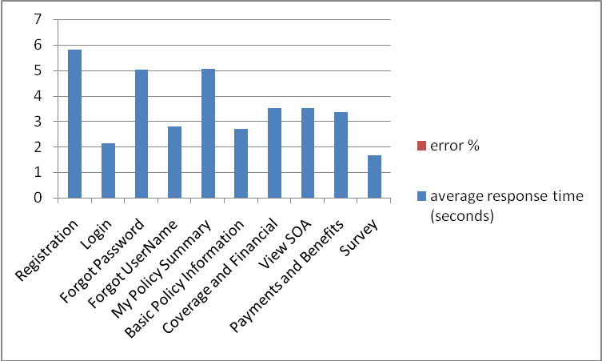

Performance Metrics based on normal load of 100 users within 100 seconds ramp up time
- The following ranks the Customer Portal pages from the longest to the shortest total average response time it took to complete each page request
Rank | Page | No. of Requests | Ave. Response Time/ Request | Cost
1 | Registration | 17 | 5.81 | 98.77
2 | Forgot Password | 6 | 5.01 | 30.06
3 | Login | 11 | 2.14 | 23.54
4 | Forgot UserName | 5 | 2.79 | 13.95
5 | Survey | 6 | 1.65 | 9.9
6 | Basic Policy Information | 3 | 2.7 | 8.1
7 | Coverage and Financial | 2 | 3.52 | 7.04
8 | View SOA | 2 | 3.51 | 7.02
9 | Payments and Benefits | 2 | 3.36 | 6.72
10 | My Policy Summary | 1 | 5.04 | 5.04

Errors Encountered
- The error below was randomly encountered while running test scripts for 800 to 1000 users. Once the error is reached, the UAT server becomes unavailable until the server is restarted.

Response headers:
HTTP/1.1 502 Bad Gateway
Date: Thu, 27 Jun 2013 02:02:41 GMT
Server: IBM_HTTP_Server

- The following errors were randomly encountered while running test scripts for 600 to 1000 users:

- java.net.ConnectException: Connection timed out: connect
- Service Temporarily Unavailable

Summary of Findings
- The <Project Name> UAT remote servers can break at a load of over 10,200 to 17,000 concurrent requests or at more than 600 users accessing the Registration page all at the same time. This problem was not encountered when we load tested up to 1000 users on the SIT environment where both UAT and Database servers are housed locally.

- Connection timed out errors were commonly encountered during load testing. These may be caused by the remote servers not being able to service all the requests at once and the connection was dropped while on queue.

- The maximum database session/connection was reached while load testing 600 to 800 concurrent user.

Recommendation
- CPI will review the most expensive functions and check where the bottlenecks are. These will be done while Phase 2 functions are being developed:
- Check if the number of http requests can be reduced
- Check images that have longer response times and optimize them
- Check for connection leaks and review connection pool
- Watch out for web services that have longer response times and submit to IT for possible tuning

- We need IT to check the following server configuration on the UAT and Production servers:
  - Is there a max number of requests configured/restricted on any of the remote servers?
  - Are there any intermediate load balancers at which requests could be dropped?

- For connection timeout errors during load testing, the network admin team can look at the network traffic to determine which end (or intermediate router) is terminating the HTTP / TCP-IP conversation and why.

- Moving the application and web servers locally will decrease network latency between the end points and improve response time.

- We need to compare the UAT and Production Servers’ specs and configuration. Performance will vary on the Production environment based on the hardware and network specification.

